General Purpose: **FDTD**, **Finite Elements**

Specific/Approximate: when certain requirements are met

**Raytracing**, **Beam Propagation**, **Eigenmode Expansion**, **Boundary Integral Equations**,

**Plane-Wave Expansion**

**RayTracing** – rarely used in PIC (on the scale of wavelength)

Shooting rays through the structure and follow path, uses high-frequency approximation

Pro: simple, accurate for large devices (not diffracting)

Con: too much approximation, not suited for on-chip waveguides

Can be used to **acquire far-field profile**

**FDTD**: generic, maxwell equation, differentiator->difference

Discretization: E and H field components are not in the same position, uses interpolation to acquire field at a position

Update the field by leapfrogging (time-stepping)

**Scaling**: **more accurate with smaller cells**, energy shouldn’t traverse more than 1 cell a step

comes larger simulation time(立方) and memory(四次方)

cube geometry – introduces anisotropy (leapfrogging updating introduces a new dispersion relation, and make propagation direction-dependent, hence anisotropic)

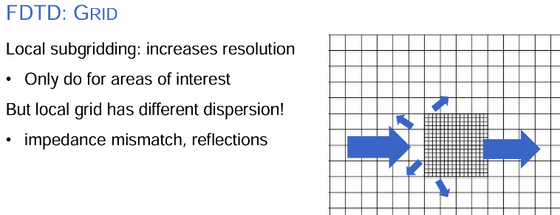

to minimize anisotropy in areas of interest: add subgrid inside, but numerical dispersion varies between them- introduce artifacts

**impedance mismatch/reflections**

Boundaries of overall volume: PEC/PMC/PML

**PEC**: Tangential E set to 0

**PMC**: Tangential H set to 0, numerically efficient but them both reflect/ bounce back

But can be quite efficient if certain that light stay bounded (waveguide modes)

However, if radiation mode exists, takes reflection into account in PEC/PMC -> PML

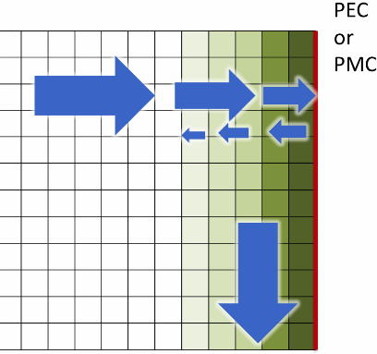**Perfectly Matched Layers (PML)**

Create layered stack of material on top of PEC/PMC with matched impedance

Gradually changing layers – **unphysical anisotropy**:

Absorbs perpendicular incidence

Guides parallel waves

Sources: Hard/Soft sources

Hard sources: set E-/H-field (like a dipole) – acts as a **scatterer** as the reflected waves hit it

Soft sources: **induce a field/using current** – transparent to reflected waves

**Convert to Frequency domain**: Fourier Transforms

H = output/input, short pulse – wide spectrum

Response to excitations takes the form of modal profiles, varies for different frequency components inside the pulse (waveguide modes are frequency dependent) - Mismatch between modal profiles of different frequencies

– applies 1550nm mode profile for calculation induces error for 1500&1600nm mode calculation – S-parameter extraction only correct for the frequency selected for mode profile

for correct response, 1 simulation correct for 1 frequency; narrowband excitation.

Need to perform simulations at different frequency to verify the frequency distortion of FDTD

Brute-force, computationally inefficient – optimized for parallelization, run on massive clusters – material setting are specialized

**Finite elements:**

**Discretization of Maxwell; Non uniform meshes (triangle/tetrahedrons)**

**Vertices: Scalar potential; Edges: Vectorial potential – current: vertex integration**

Optimize locally with fine meshes – easier to discretize curved geometries

Open boundary by nature – introduce PML boundary

2 most common, generic methods – specific structure

**Plane-wave expansions:** describe the field as superposition of plane waves, calculate coupling between waves by scatterers (scatter and couple)

Solving for eigenvalues (band diagrams) or excitation-driven, easy far-field calculations

Plane waves are eigenmode for free space, discontinuities are hard to express

**Pro:** simple base set, standard fourier transform

**Con:** many waves needed, difficult to describe **discontinuities (waveguides不连续边界)**

**Eigenmode expansion:** to deal with discontinuities description

Discretize structure into parts transversally invariant, and describe the field as series of eigenmodes in that section (lower degree of freedom/number to express the field);

at interfaces, **coupling matrix** needs to be calculated (**difficulty!-find all eigenmodes!**)

– acceptable for real materials,

suitable for components with **large area with same cross-sections**, propagate instantaneous

Gradual changes in cross-section – chop into sections, inefficient simulations (mode overlap)

Speed-up for **periodic structures (gratings)**

**Advantage: no need to solve all the fields if only S-matrix is needed**

**Not suitable for structures with a lot of variation in cross-section profile**

**Beam propagation**: discretization of paraxial wave equations (propagate in one direction)

extended with reflections, wide angles

**Pro: fast, large devices, includes radiation**

**Con:** perturbation theory - **low index contrast (not for silicon photonics)**

**Boundary Integrals: Rayleigh-Sommerfeld,**

fields can be determined by boundary conditions, no need to go through volume

easy for transmission through uniform areas (star-coupler, AWG, echelle gratings)